**HOME WORK FIVE Qian Yu**

**ST635 Intermediate Statistical Modeling for Business Fall 2017**

**Exercise Section 10.7: Problem 8, Problem 9**

**Problem 8**

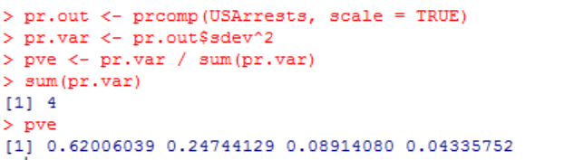

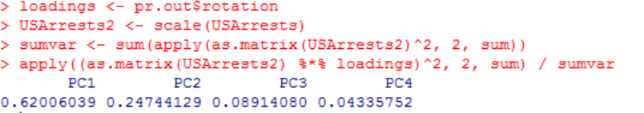

**Problem 9**

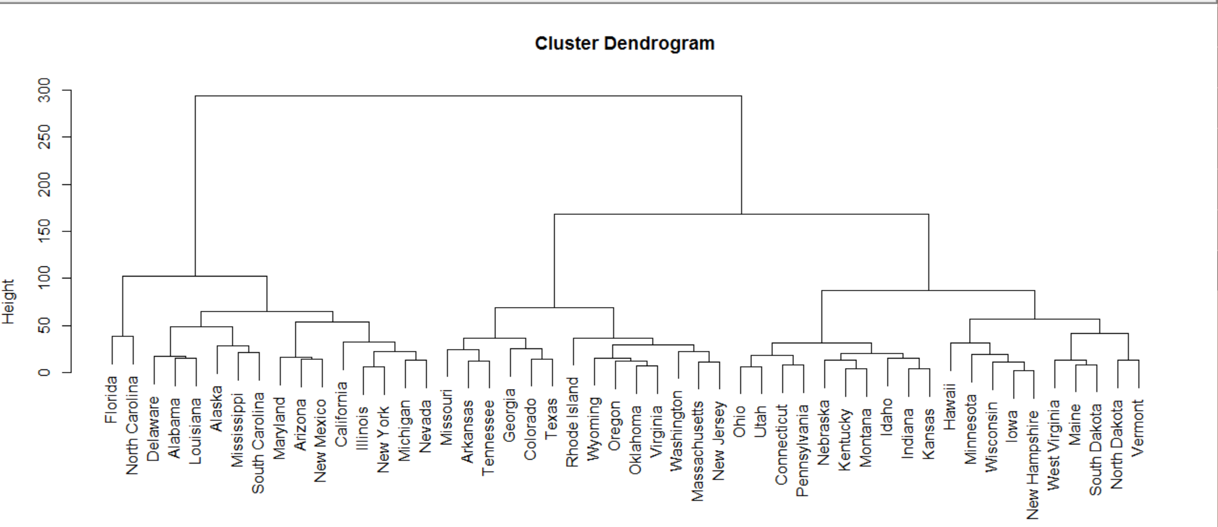

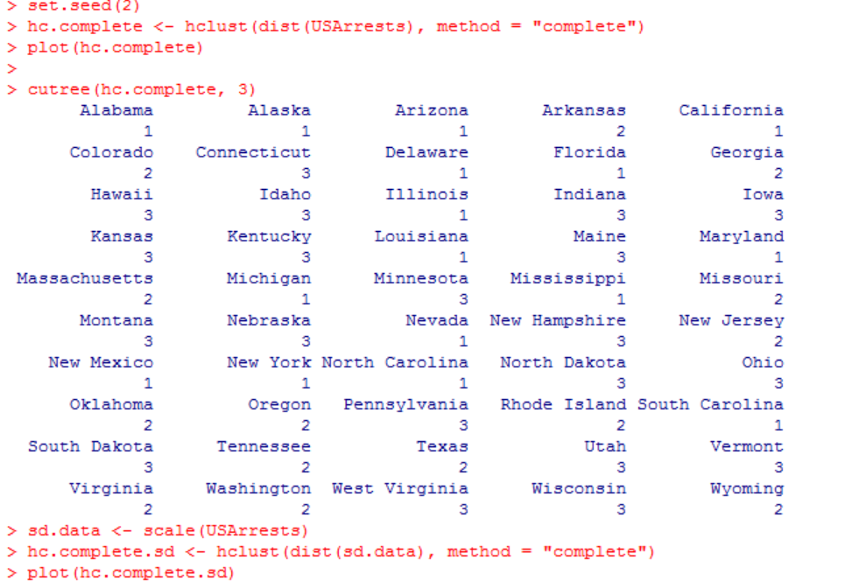

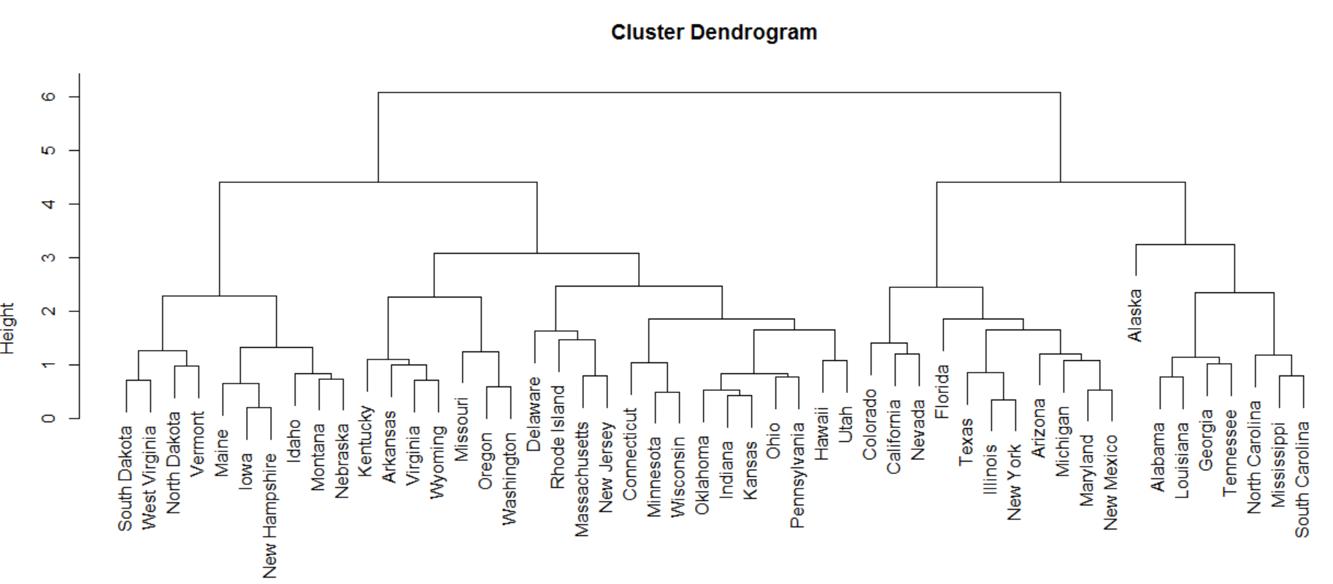

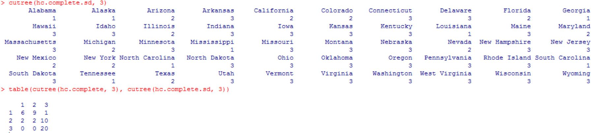

In my opinion, the variables should be scaled before the inter-observation dissimilarities are computed, because the data measures have different units, even though the trees are similar.